**7. ReactJS-HOL**

**Cart.js**

import React, { Component } from 'react';

class Cart extends Component {

render() {

return (

<tr>

<td>{this.props.itemname}</td>

<td>{this.props.price}</td>

</tr>

);

}

}

// Default props (optional fallback)

Cart.defaultProps = {

itemname: "Unknown Item",

price: "0"

};

export default Cart;

**OnlineShopping.js**

import React, { Component } from 'react';

import Cart from './Cart';

class OnlineShopping extends Component {

render() {

const items = [

{ itemname: 'Laptop', price: 80000 },

{ itemname: 'TV', price: 120000 },

{ itemname: 'Washing Machine', price: 50000 },

{ itemname: 'Mobile', price: 30000 },

{ itemname: 'Fridge', price: 70000 }

];

return (

<div style={{ textAlign: 'center' }}>

<h2 style={{ color: 'green' }}>Items Ordered :</h2>

<table border="1" align="center" cellPadding="10" style={{ borderCollapse: 'collapse' }}>

<thead>

<tr>

<th>Name</th>

<th>Price</th>

</tr>

</thead>

<tbody>

{items.map((item, index) => (

<Cart key={index} itemname={item.itemname} price={item.price} />

))}

</tbody>

</table>

</div>

);

}

}

export default OnlineShopping;

**App.js**

import React from 'react';

import ReactDOM from 'react-dom/client';

import App from './App';

const root = ReactDOM.createRoot(document.getElementById('root'));

root.render(<App />);

**Index.js**

import React from 'react';

import OnlineShopping from './OnlineShopping';

function App() {

return <OnlineShopping />;

}

export default App;

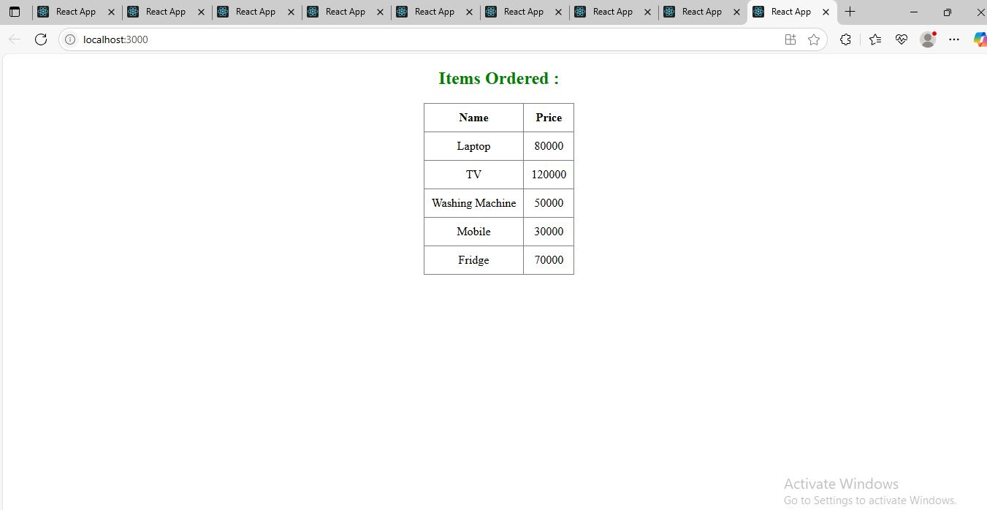

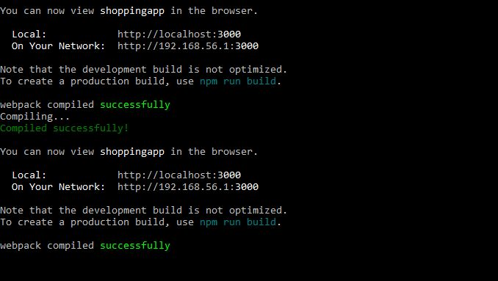

**Define Props**

**Props** (short for **properties**) are **read-only attributes** passed from a **parent component to a child component** in React.  
They are used to pass **data**, **functions**, or **configuration** between components.

**Example:**

function Welcome(props) {

return <h1>Hello, {props.name}</h1>;

}

You can use this component like:

<Welcome name="Sajitha" />

**Explain Default Props**

**Default props** provide **default values** for props that are not passed by the parent component.

**Example:**

function Welcome(props) {

return <h1>Hello, {props.name}</h1>;

}

Welcome.defaultProps = {

name: "Guest"

};

If name is not provided, "Guest" will be used.

**Identify the Differences Between State and Props**

| **Feature** | **Props** | **State** |
| --- | --- | --- |
| Definition | Data passed from parent to child | Data managed **inside** the component |
| Mutability | **Immutable** (read-only) | **Mutable** (can be changed with setState) |
| Access | this.props (class) / props (func) | this.state / useState() (hook) |
| Purpose | Configuration and communication | Handling dynamic or interactive data |
| Ownership | External (from parent) | Internal (owned by the component) |

**Explain reactDOM.render()**

ReactDOM.render() is the **entry point** to render a React component into the DOM. It tells React **what to render and where to render it**.

**Syntax:**

ReactDOM.render(<App />, document.getElementById('root'));

* <App /> → The component to render
* document.getElementById('root') → The target DOM element (usually in index.html)

From React 18 onwards, ReactDOM.createRoot(...).render(...) is used instead of ReactDOM.render().